Guidelines for Students Taking the ATI TEAS
Mott Community College
Nursing Program

At Mott Community College, the Nursing Program requires prospective students to take the ATI TEAS as part of the basic eligibility requirements for entry into the Associate degree in Nursing program. The TEAS measures basic essential skills and helps to determine if students are ready to begin the program.
What is the ATI TEAS?

The TEAS, or Test of Essential Academic Skills, is a test created by Assessment Technologies Institute. The TEAS is designed specifically to assess a student's preparedness entering the health science fields. The ATI TEAS test is comprised of 170 questions set up in a multiple-choice format with four-option answers. Questions are designed to test the basic academic skills in the areas of: Reading, Math, Science, and English and Language Usage. What score do I need to achieve on the ATI TEAS?

Although scores are posted for all four content areas, Mott’s Nursing Program uses the Academic Preparedness Level to help determine if a student is ready to begin the Nursing Program.

There are five Academic Preparedness Levels that a student could earn on the TEAS:
- Developmental
- Basic
- Proficient
- Advanced
- Exemplary

The Academic Preparedness Level that is required for Mott’s Nursing Program is a Proficient Level or higher. (See the sample score report on next page. The Academic Preparedness Level is circled on the sample report.)

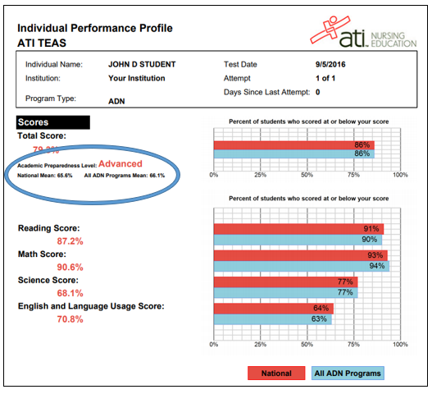

When should I take the TEAS?

The TEAS must be taken at least 30 days prior to the Nursing Program application deadline. (This allows for adequate time for a second attempt to be done, if necessary.)

The Nursing Program recommends taking the TEAS shortly after completing the pre-requisite Anatomy and Physiology courses.

Where can I take the TEAS?

To qualify for Mott’s Nursing Program, students must take the TEAS at Mott’s Testing Center. We will not accept results from another institution.

The Mott Testing Center is located on the 3rd floor of the Mott Library (ML3107).
How do I register for the TEAS?

You will need to create an account with ATI to register. Go to the ATI website (ATI testing website) and select the option ‘create an account.’ Follow the prompts to create an account.
After creating an account with ATI, the student needs to contact Mott’s Testing Center (810-762-0406) to schedule a test date/time.

What is the cost of the TEAS? How do I pay for it?

Currently, the cost of the TEAS is $65. (This is subject to change.) You will pay for the TEAS online at the time of the testing at Mott’s Testing Center. To pay, you will need to bring a valid credit or debit card. All orders are final, with no refund.

Is there a time limit for the TEAS?

Yes. Students are allotted 209 minutes (approximately 3 ½ hours) to complete 170 questions on the TEAS.
Is there a limit on how many times I can take the TEAS?

Yes, there is a limit. Students may only take the TEAS twice at Mott Community College.

If a student does not earn a Proficient Level on the first attempt at the TEAS, the student will need to take the TEAS again. The student must wait at least 30 days before retesting, and it is expected that the student will use the time to prepare for the next attempt.

How should I prepare to take the TEAS?

ATI recommends at least 6 weeks of preparation prior to taking the TEAS. Students can prepare by reviewing an ATI TEAS prep manual at Mott’s Library. The manuals are available for loan. Students can also purchase other study aids for the TEAS online.

Additionally, ATI has developed a variety of prep products to help students pass the exam on the first attempt and earn a great score. The products include a SmartPrep Tutorial, an Online Practice Assessment, and a Study Manual. These products are available online (https://www.atitesting.com/teas-prep) and have various associated costs.

What if I need special accommodations for testing?

Accommodations can only be made if a student self-discloses that they have a disability and need accommodations. Students must provide official documentation (Instructor Notification Form) to the Testing Center prior to the test date. This form is secured through Disability Services at Mott.

As an affirmative action/equal opportunity institution, the College encourages diversity and provides equal opportunity in education, employment, all of its programs, and the use of its facilities. The College does not discriminate in educational or employment opportunities or practices on the basis of race, sex, color, religion, gender, gender expression, gender identity, national origin, veteran’s status, age, disability unrelated to an individual’s ability to perform adequately, sexual orientation, or any other characteristic protected by law.

Title IX Coordinator Contact Information:
1401 E. Court St., Prahl College Center – Student Success Services Center (PCC-2280E), Flint, MI 48503, (810) 762-0024.

Title II, ADA, Coordinator Contact Information:
1401 E. Court St., Curtice-Mott Complex (CM-1117, Flint, MI 48503 (810) 762-0373.

Section 504 Coordinator Contact Information:
1401 E. Court St., Prahl College Center (PCC-2280A), Flint, MI 48503 (810) 232-2557.

